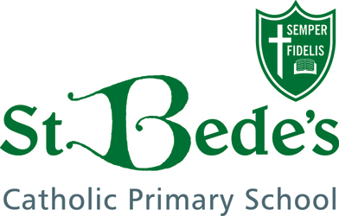

**ACHIEVING EXCELLENCE TOGETHER**

**Inspiring independent learners with Jesus by our side**



**VACANCY**

**MIDDAY ASSISTANT**

St Bede’s Catholic Primary School wish to appoint a Midday Assistant to join our dedicated team of staff at lunchtime for one hour each day 12noon – 1.00pm.



**DO YOU…**

Enjoy working with children?

Want to support our children to have happy, healthy lunchtimes?

Like playground games?

Have lots of enthusiasm?

**Our children would like you to be…**

helpful, understanding, patient, caring, calm and fun!

**Salary: *Local Living Wage £12 per hour***

**If you would like to apply for this position please contact the school office for further details** [**admin@st-bedes.cheshire.sch.uk**](mailto:admin@st-bedes.cheshire.sch.uk) **/01606 852149**

**or call in to the office to find out more.**

*St Bede’s Catholic Primary School places the highest priority on Safeguarding and promoting the welfare of children and young people. The successful candidate will be subject to the relevant checks and enhanced DBS (Disclosure & Barring Service check).*